**NUMERICAL PREDICTION ANALYSIS USING LINEAR**

**REGRESSION**

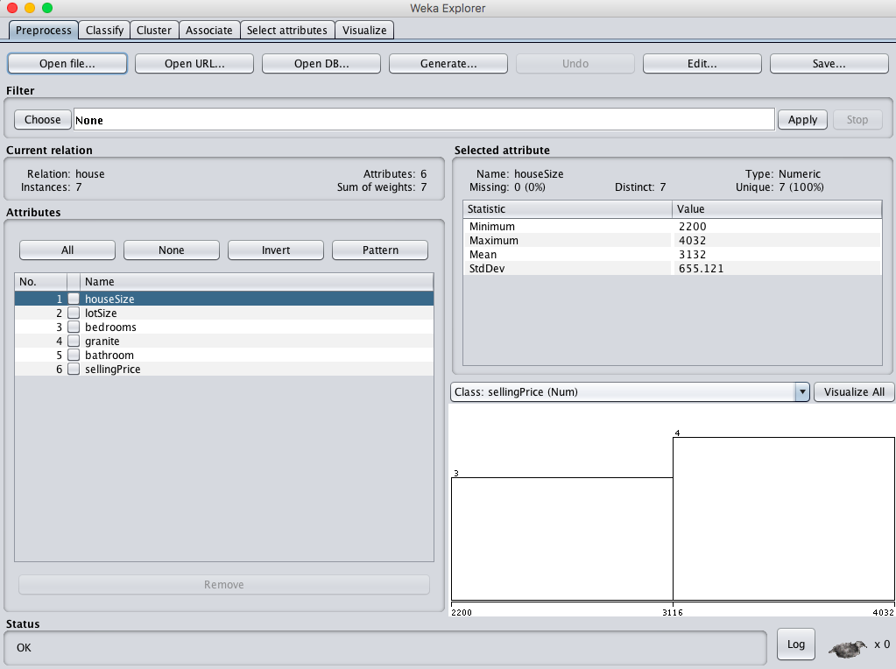

**1.When cross validation folds = 05 :**

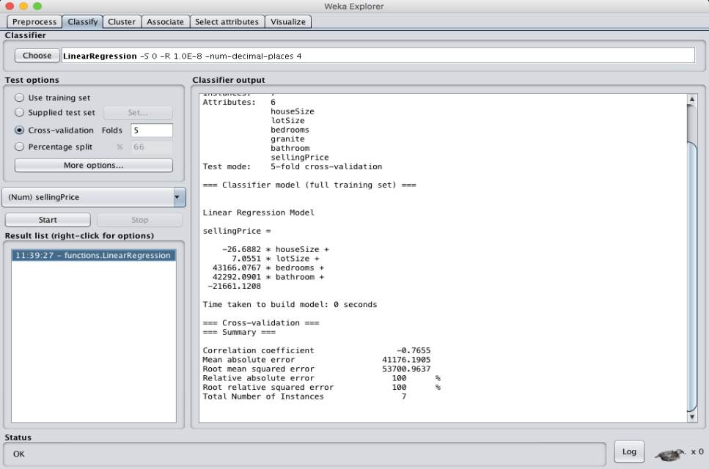

**2.When cross validation folds = 10 :**

